**Car Price Prediction Using Ensemble Method**

**A Project Report**

**Submitted by:**

Aman Kumar Kasaudhan (S.Id :2019008353)

Vankayala Sri Sailaja (S.Id : 2019008425)

Nibbritta Niloy Sarker Tanmoy (S.Id : 2019008292)

**Under the guidance of :**

Mrs. Kanika Singla & Mr. Dharm Raj



**BACHELOR OF TECHONOLOGY**

**IN**

**COMPUTER SCIENCE AND ENGINEERING**

**3rd Year 5th Semester**

At

**SHARDA UNIVERSITY**

**Knowledge Park III, Greater Noida, Uttar Pradesh 201310**

**ACKNOWLEDGMENT**

I hereby declare that the project work entitled as “ **Car Price Prediction Using Ensemble Method** ” submitted to the **SHARDA UNIVERSITY** , is the fruitful result of intense work done by our group under guidance of **Mrs. Kanika Singla** & **Mr . Dharm Raj** , SUSET ,  **Department of Computer Science and Engineering** . Our journey from learning to delivering new tech based product owes sincere regards to our Professors for making us capable in receiving Bachelors of Technology 2019 - 2023.

I am also glad to declare that this project report has not been previously submitted to any other University.

Date : 01/12/2021

Place : Greater Noida

**ABSTRACT**

This project illustrates a case study in which we used Machine Learning ideas and compared various Regression Algorithms to create a model for used car price prediction with high accuracy as a regression model. The MSLE and RMSLE scores were better with XGBoost. With 25 projections and 509577 data entries, we calculated the price of secondhand cars. XGBoost is a method of ensemble learning. Gradient Boosted Decision Trees include XGBoost, which is used for  high speed performance and accuracy, With an accuracy of 89.662 percent, the XGBoost register outperforms other models.

**INDEX**

##### S.No. TOPICS

Abstract

##### INTRODUCTION

Problem Statement

Problem Overview

Requirnment and Specification

Algorithms

**2 SYSTEM ANALYSIS & DESIGN** Design and Test Steps / Criteria Algorithms and Pseudo Code Testing Process

##### RESULTS

1. **CONCLUSIONS**
2. **REFERENCES**
3. **Introduction**
   1. **Problem Statement**

Despite tremendous developments in the auto industry,there are many people who prefer used cars,feeling that they are of higher quality,and are less expensive,moreover they may prefer older cars because of their ease of handling.They are not having sophisticated technology as they do,which makes it easier for them to use.According to the survey, the used car market in India was worth US$27 billion in 2020,and is expected to reach US$50 billion by 2020.The COVID-19 pandemic had negligible impact on the industry.The decrease in the rate of cash flow due to the pandemic has forced buyers to opt for second hand cars,With the pandemic hampering sales and production of new vehicles,the only option for buyers is the used cars.The pre-owned car market recorded sales of 4.4 million units in FY20,while new commuters sold only 2.8 million units.vehicle in the same year.So these facts look at the importance of the developed used car market in the country.

* 1. **Problem Overview**

The researchers provided some possible evidence for this effect.They checked that the price usually depends on various features which is the most dominant brand and model,age,kms driven and mileage.The odometer reading also has a significant impact on a car's valuation.A car that is old on paper has become obsolete as per the norms of the country's automotive authorities,which would make it unfit to drive on the road,be it the odometer reading.Hence,a car that has been used less and has only 2-3 years of life left is considered as scrap,until we come up with measures that will practically last till the condition of each car.and provide fitness certificate accordingly.So in this paper we have applied various methods and techniques to get high accuracy of used car price prediction.

The main objective of our research is to apply a machine-learning approach to forecasting used car prices and to address the following questions:[3]Can machine learning based models make accurate predictions of a used car?Which features selection can highly impact performance?Can we get comparable or relatively high prediction performance by introducing the ensemble method?The structure of this paper is organized as follows.Section 2 depicts factors based on car price after literature review and Section 3 depicts the role of feature selection,prior to that how data is prepared and the various regression models are applied and their outcomes.Section 4 contains results and hence prooving that XGBoost(Ensemble Method)giving best MSLE(Mean Square Log Error)and RMSLE(Root Mean Square Log Error)Section 5 breifs about the process from data preprocessing to experimental

* 1. **Requirnment and Specification**

**Hardware requirements-**

Processor:486 dx4 or above

RAM: 16 MB

**Software requirements-**

Platform Used : Anaconda , Jupyter Notebook

Libraries Used : Numpy , Pandas Data Visualization tools : Matplotlib , Seaborn

Deployment : Flask

* 1. **Algorithms Used**

The dataset is supervised and the models are applied in a below given order:

* [Linear Regression](https://scikit-learn.org/stable/modules/generated/sklearn.linear_model.LinearRegression.html)
* [Ridge Regression](https://scikit-learn.org/stable/modules/generated/sklearn.linear_model.ridge_regression.html)
* [Lasso Regression](https://scikit-learn.org/stable/modules/generated/sklearn.linear_model.Lasso.html)
* [K-Neighbors Regressor](https://scikit-learn.org/stable/modules/generated/sklearn.neighbors.KNeighborsRegressor.html)
* [Random Forest Regressor](https://scikit-learn.org/stable/modules/generated/sklearn.ensemble.RandomForestRegressor.html)
* [Bagging Regressor](https://scikit-learn.org/stable/modules/generated/sklearn.ensemble.BaggingRegressor.html)
* [Adaboost Regressor](https://scikit-learn.org/stable/modules/generated/sklearn.ensemble.AdaBoostRegressor.html)
* [XGBoost](https://xgboost.readthedocs.io/en/latest/)

1. **System Analysis and Design**

**Methodology:**

1. **The DataSet:**

The dataset used in this project has been taken from[Kaggle](https://www.kaggle.com/austinreese/craigslist-carstrucks-data)presented in csv format.

**2 .Data Preparation:**

Before processing data we have to remove unnecessary features like url,transmission,colour,county,state,owner details from the dataset and in next step,we will check for missing values for each feature.

1. **Data preprocessing:**

**Label Encoder**: In our dataset,12 features are categorical variables and 4 numerical variables(excluding the value column).To implement ML model,we need to convert these categorical variables into numerical variables and LabelEncoder Library of S K Learn is used.

**Normalization :** The dataset is not normally distributed.All facilities have different categories.Without normalization,the ML model will attempt to disregard the coefficients of features that have low values​​because their effect will be much smaller than that of the larger value.So to generalize,the sklearn library i.e.MinMaxScaler is used.

Train the data: In this method, 90% of the data was split into train data and 10% was used as test data.

**4.ML Models**: In this section,various machine learning algorithms are used to predict the value/target-variables.

1. Linear Regression :

A linear technique to modelling the relationship between a scalar response (or dependent variable) and one or more explanatory variables is known as linear regression in statistics (or independent variables). Relationships are modelled using linear predictor functions whose unknown model parameters are derived from data in linear regression. Linear models are a type of model that fits this description.

**IMG_256**

Coefficients:

The direction of the link between a predictor variable and a responder variable is shown by the sign of each coefficient.

There are two signs Positive and Negative indicating directly proportionality of the predictor and response variable.

**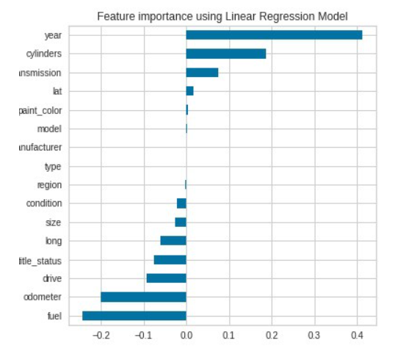**

**Graph showing important feature**

In this figure, linear regression shows that the five variables are the year, cylinder, transmission, fuel, and odometer**.**

**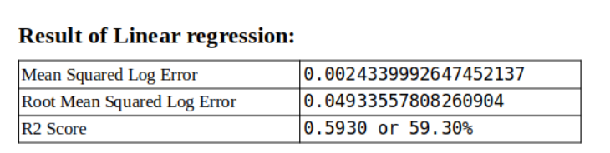**

1. Ridge Regression:

In cases where the independent variables are highly correlated, ridge regression is a method of calculating the coefficients of multiple-regression models. Yellowbrick library alpha selection was used to identify the best alpha value in ridgeregression.

Only dataset can be fit if the alpha value is 20.336. It is a variable, even though it is not a constant value. The Ridge regressor is implemented with this alpha value.

**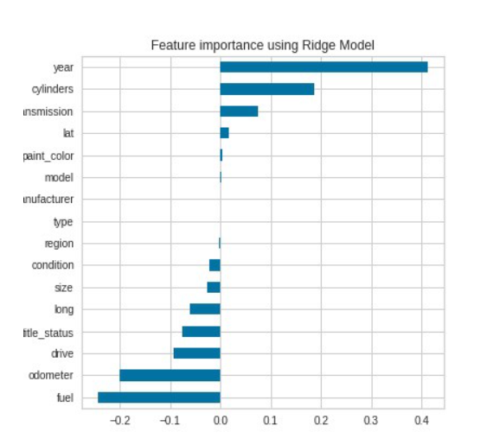**

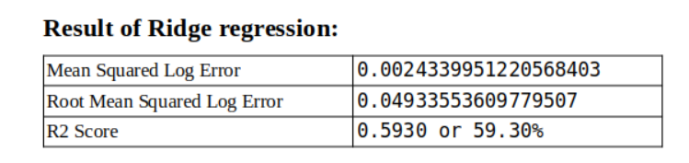

The accuracy and performance of Ridge Regression is almost equal to that of Linear Regression.

3)Lasso Regression:

Lasso regression is a shrinkage-based linear regression. When data values shrink towards a central point, such as the mean, this is known as shrinkage. The Lasso method favours the use of simple, sparse models (i.e. models with fewer parameters)

The fundamental goal of Lasso regression is to find a group of predictors that decreases the quantitative response variable's prediction error. The Lasso model accomplishes this by imposing a parameter constraint that leads the regression coefficients for some variables to decrease toward zero.

**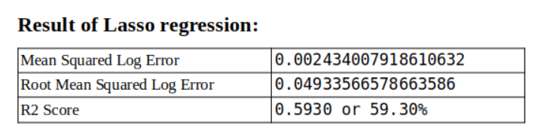**

But for this dataset, there is no need for Lasso regression as there is not much difference in error.

4)KNeighbors Regressor:

Regression-based on k-nearest neighbors. Target prediction is done by local insertion

of targets connected to the nearest neighbors of the training set.

k-NN is a type of example-based learning, or lazy learning, where the function is only locally approximated and all computation is postponed until function evaluation.

**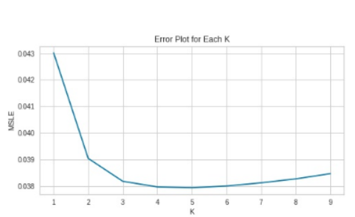**

**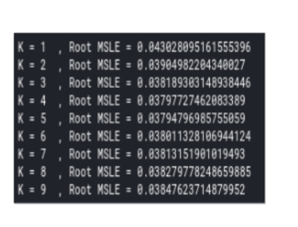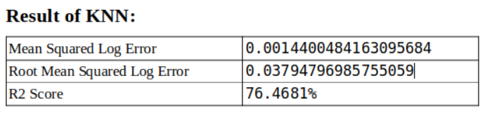**

The performance of KNN is better and the error is decreasing with the increased accuracy.

5) Random Forest:

A random forest is a decision tree-based categorization technique. When constructing each tree, it employs bagging and feature randomization in order to produce a fragmented forest of trees whose committee forecasts are more accurate than any one tree's.

There were 180 max features 0.5 choices made in our model.

**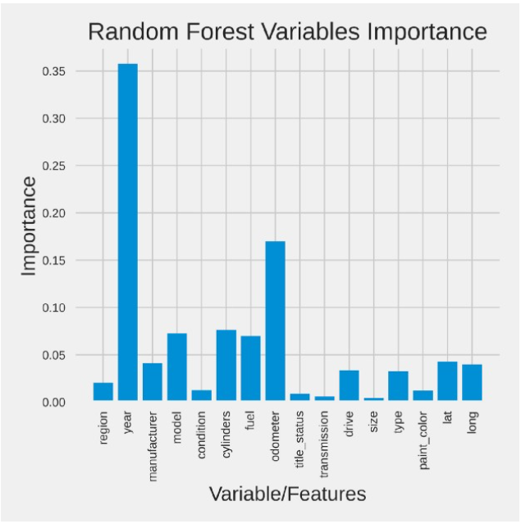**

This is a simple bar plot showing that the year is the most important characteristic of a car and then the odometer variable and then the others.

**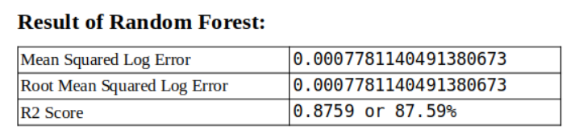**

Random forest has better performance and increases accuracy to approx. 10% which is good. Since the random forest is using bagging while building each tree, the next bagging register will be done

6) Bagging Regressor:

The term "bagging" refers to a form of ensemble regressor. It's a meta-estimator that fits each of the base regressors to a random subset of the original dataset and then averages or polls their predictions to create the final prediction. It is used to minimise the variance of a black-box estimator (such as a decision tree) by including randomization into the construction process and then grouping the results.

DecisionTreeRegressor is employed as an estimator in this model, with a depth of 20 and 50

decision trees.

**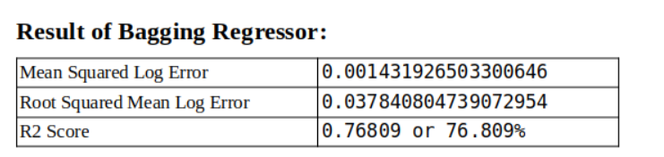**

7) Adaboost regressor:

It's used to help any machine learning algorithm perform better. Adaboost assists you in combining several "weak classifiers" into a single "strong classifier."

It's a basic bar graph that indicates that the most essential feature of an automobile is the year, followed by the odometer variable, model, and so on.

The DecisionTreeRegressor is utilised as an estimator in our model, with a maximum depth of 24 and 200 trees produced, and a learning rate of 0.6, as shown below.

**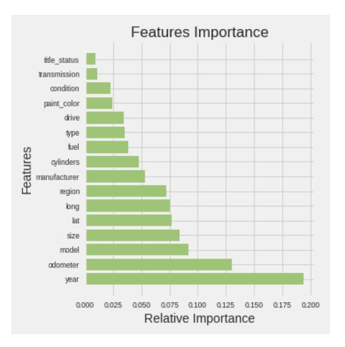**

**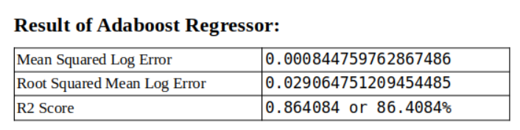**

8) XGBoost ( eXtreme Gradient Boosting )

XGBoost is a method for ensemble learning. Gradient Boosted Decision Trees include XGBoost, which is utilised for speed and performance. The beauty of this strong algorithm is its scalability, which allows for quick learning via parallel and distributed computing while still conserving memory. **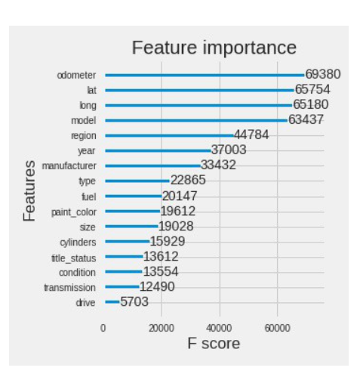**

It's simple bar plot in descending importance which shows which attribute/variable is an important characteristic of a car which is more important.

According to XGBoost, the odometer is an important feature while the year is an important feature from the previous model**.**

**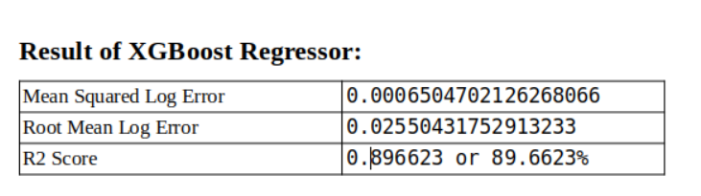**

**3.Results and Discussion**

Hence after performing tests using all supervised learning regression algorithms,we conclude few observations.We analyze that the diesel variant car costs more then the electric variant costs.Hybrid variant cars cost the lowest.We analyze that the car price of the respective fuel also depends on the condition of the car.Condition of the car also plays vital role in price prediction.

**4. Conclusion**

By performing different ML models,we aim to achieve better results or less error with maximum accuracy.Our objective was to estimate the price of used cars with 25 predictions and 509577 data entries.Data cleaning is done to remove null values.Then various models were implemented,but the maximum accuracy was recieved in XG Boost(Ensemble Method).As a regression model XGBoost gave the best MSLE and RMSLE values.

**5. References**

1. <https://www.mordorintelligence.com/industry-reports/india-used-car-market>
2. <https://autoportal.com/articles/factors-which-affect-used-car-valuation-price-6446.html>
3. <file:///C:/Users/sharda/Downloads/oil%20price%20prediction%20using%20ensemble%20method.pdf>
4. <http://www.lingcure.org/index.php/journal/article/view/1660>
5. S.Pudaruth,“Predicting the Price of older Used Cars using Machine Learning
6. Techniques,”International Journal of Information&Computation Technology,vol.4,no.7,pp.753–764,2014.
7. N.Kanwal“Vehicle Price Prediction System using Machine Learning Techniques”
8. S.Peerun,N.H.Chummun,and S.Pudaruth,“Predicting the Price of Second-hand Cars using Artificial Neural Networks,”The Second International Conference on Data Mining,Internet Computing,and Big Data,no.August,pp.17–21,2015.
9. <https://sci-hub.zidianzhan.net/>

[10]<https://towardsdatascience.com/used-car-price-prediction-using-machine-learning-e3be02d977b2>